SQL HANDS-ON DAY2
ANSWERS

1. Create Customer table
CREATE TABLE Customer (
Customer_ID INT PRIMARY KEY,
Customer_Name VARCHAR(100),
Email VARCHAR(100)
);

2. Insert 3 records into Customer table
INSERT INTO Customer VALUES (1, 'Arun', 'arun@gmail.com');
INSERT INTO Customer VALUES (2, 'Meera', 'meera@gmail.com');
INSERT INTO Customer VALUES (3, 'Rahul', 'rahul@gmail.com');

3. Create Orders table
CREATE TABLE Orders (
Order_ID INT PRIMARY KEY,
Customer_ID INT,
Order_Amount DECIMAL(10,2)
);

4. Insert 3 records into Orders table
INSERT INTO Orders VALUES (101, 1, 250.00);
INSERT INTO Orders VALUES (102, 2, 150.00);
INSERT INTO Orders VALUES (103, 1, 500.00);

5. Display all data from Customer table
SELECT * FROM Customer;
Output
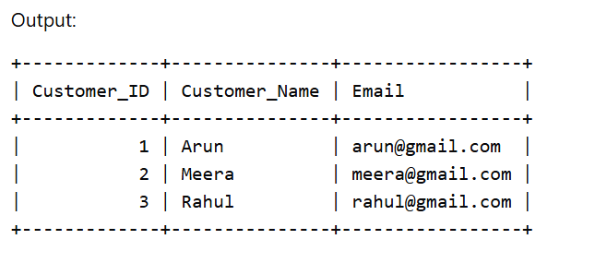
6. Retrieve only Customer_Name column
SELECT Customer_Name FROM Customer;
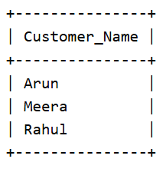
7. Insert one more record with NULL Email
INSERT INTO Customer VALUES (4, 'Sneha', NULL);

8. Find customers with Customer_ID = 1
SELECT * FROM Customer
WHERE Customer_ID = 1;
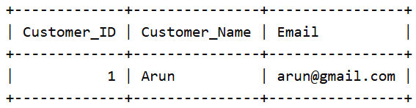
9. Retrieve customers whose Email is NULL
SELECT * FROM Customer
WHERE Email IS NULL;
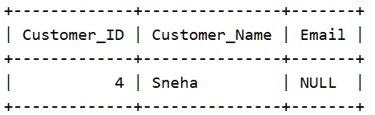
10. Get all orders where Order_Amount > 200
SELECT * FROM Orders
WHERE Order_Amount > 200;
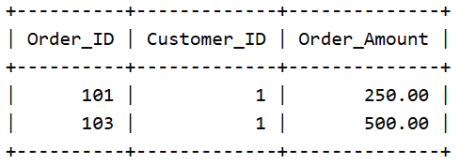
11. Display customers sorted by Customer_Name ascending
SELECT * FROM Customer
ORDER BY Customer_Name ASC;
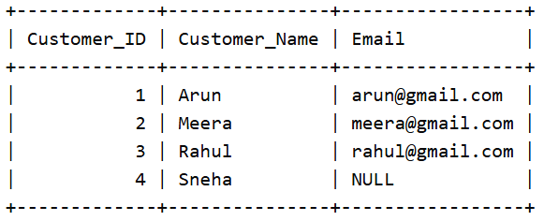
12. Retrieve orders sorted by Order_Amount descending
SELECT * FROM Orders
ORDER BY Order_Amount DESC;
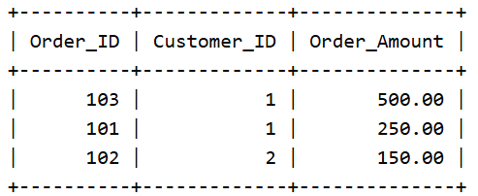
13. Display Customer_Name as Name using alias
SELECT Customer_Name AS Name
FROM Customer;
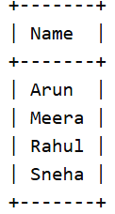
14. Use table aliases
SELECT c.Customer_Name, o.Order_Amount
FROM Customer c
JOIN Orders o
ON c.Customer_ID = o.Customer_ID;
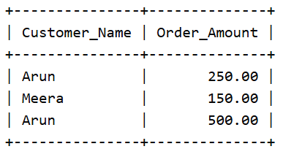

15. Display customers along with their orders using INNER JOIN
SELECT c.Customer_Name, o.Order_ID, o.Order_Amount
FROM Customer c
INNER JOIN Orders o
ON c.Customer_ID = o.Customer_ID;
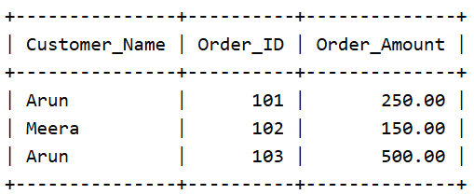
16. Display all customers even if they don’t have orders
SELECT c.Customer_Name, o.Order_ID, o.Order_Amount
FROM Customer c
LEFT JOIN Orders o
ON c.Customer_ID = o.Customer_ID;
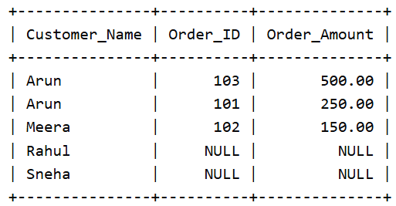
17. Display all orders even if customer details are missing
SELECT c.Customer_Name, o.Order_ID, o.Order_Amount
FROM Customer c
RIGHT JOIN Orders o
ON c.Customer_ID = o.Customer_ID;
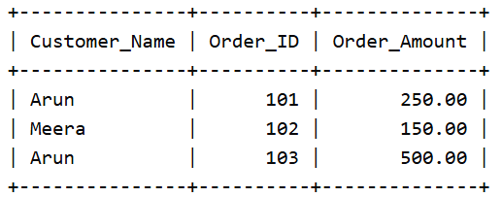
18. Replace NULL Email values with 'No Email'
SELECT Customer_ID,
Customer_Name,
COALESCE(Email, 'No Email') AS Email
FROM Customer;
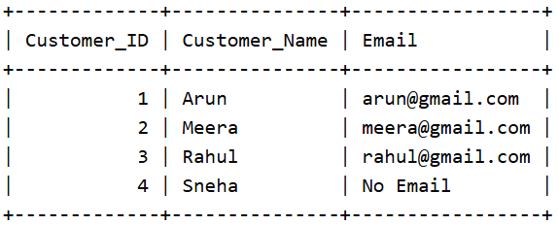
19. Update email of a specific customer
UPDATE Customer
SET Email = 'newmail@gmail.com'
WHERE Customer_ID = 2;

20. Delete customer with specific Customer_ID
DELETE FROM Customer
WHERE Customer_ID = 4;

